[](http://thumbs.dreamstime.com/z/page-exercises-kids-coloring-book-illustration-children-happy-colorful-31011090.jpg)

[](http://kootation.com/royalty-free-stock-photography-coloring-book-of-the-works-25/thumbs.dreamstime.com*z*coloring-book-works-25-musician-15028937.jpg/)

[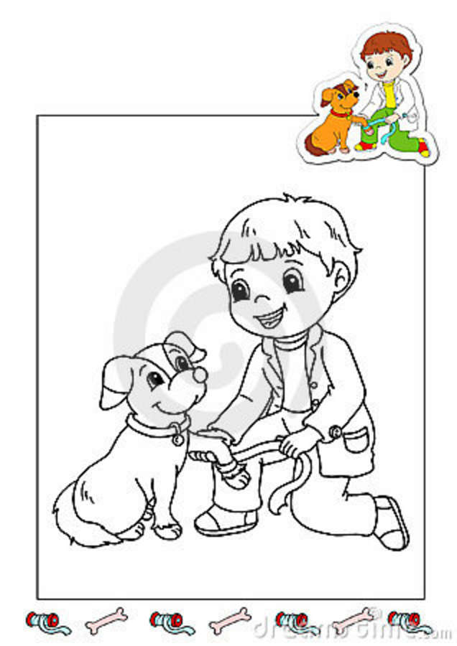](http://kootation.com/coloring-book-of-the-works-27-veterinarian-royalty-free-stock-photos/thumbs.dreamstime.com*z*coloring-book-works-27-veterinarian-15029648.jpg/)

[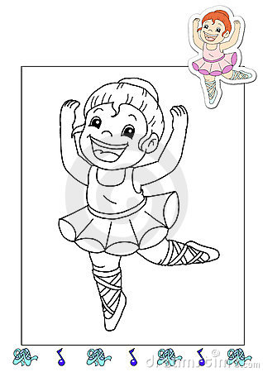](http://kootation.com/coloring-book-of-the-works-2-dancer-royalty-free-stock-photography/dreamstime.com*coloring-book-of-the-works-2-dancer-thumb14782777.jpg/)

[](http://thumbs.dreamstime.com/z/coloring-book-works-33-farmer-15355773.jpg)

[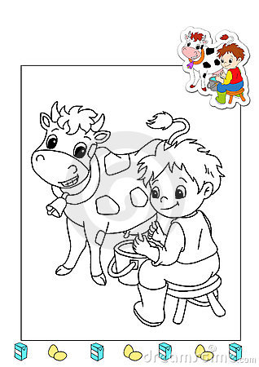](http://thumbs.dreamstime.com/z/coloring-book-works-12-agriculturist-15019139.jpg)

[](http://thumbs.dreamstime.com/z/coloring-book-works-10-bread-s-man-15012333.jpg)

[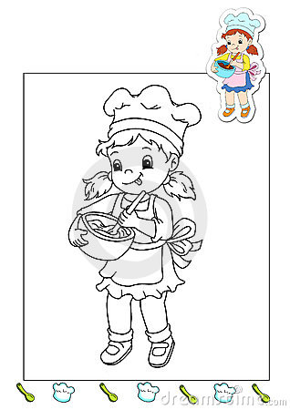](http://thumbs.dreamstime.com/z/coloring-book-works-13-cook-15019149.jpg)

[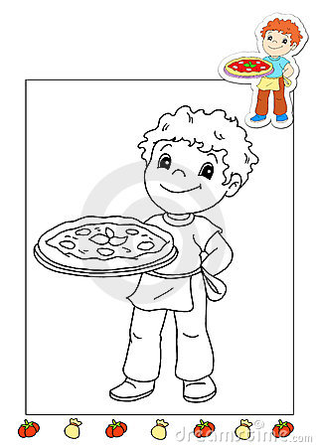](http://thumbs.dreamstime.com/z/coloring-book-works-8-pizza-14790975.jpg)

[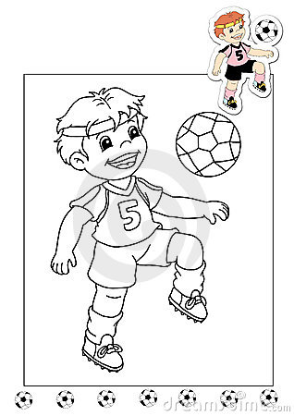](http://thumbs.dreamstime.com/z/coloring-book-works-29-soccer-player-15139854.jpg)

[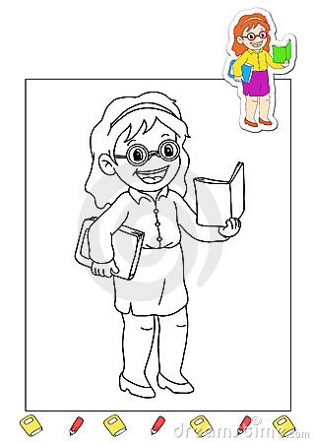](http://thumbs.dreamstime.com/z/coloring-book-works-7-teacher-14790971.jpg)

[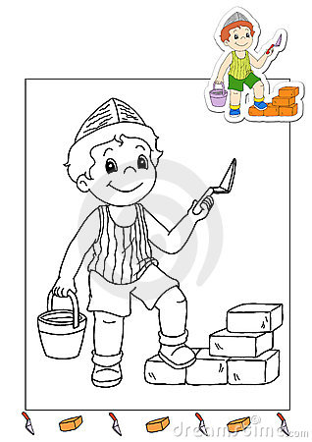](http://thumbs.dreamstime.com/z/coloring-book-works-9-mason-14790981.jpg)

[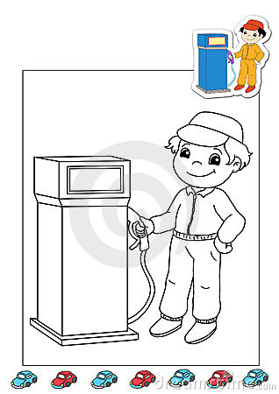](http://thumbs.dreamstime.com/z/coloring-book-works-38-gas-station-attend-15371881.jpg)

[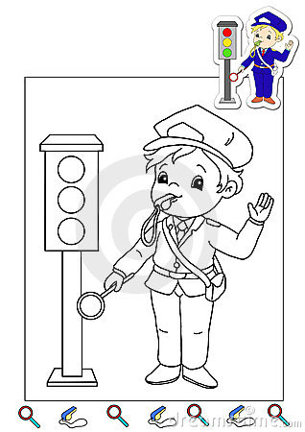](http://thumbs.dreamstime.com/z/coloring-book-works-35-vigilant-15355797.jpg)

[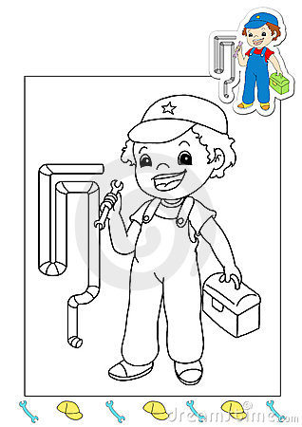](http://thumbs.dreamstime.com/z/coloring-book-works-34-hydraulic-15355786.jpg)

[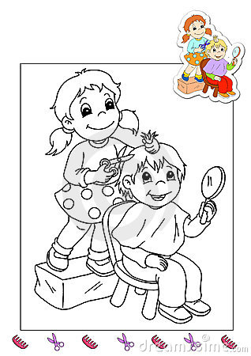](http://thumbs.dreamstime.com/z/coloring-book-works-31-hairdresser-15139933.jpg)

[](http://thumbs.dreamstime.com/z/coloring-book-works-28-writer-15029659.jpg)

[](http://thumbs.dreamstime.com/z/coloring-book-works-26-mail-carrier-15029637.jpg)

[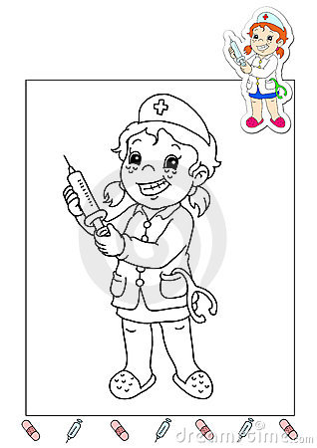](http://thumbs.dreamstime.com/z/coloring-book-works-32-nurse-15159160.jpg)

[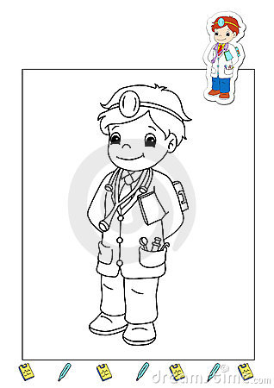](http://thumbs.dreamstime.com/z/coloring-book-works-23-doctor-15028922.jpg)

[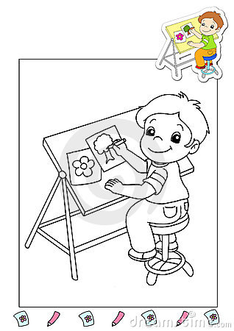](http://thumbs.dreamstime.com/z/coloring-book-works-36-illustrator-15355814.jpg)

[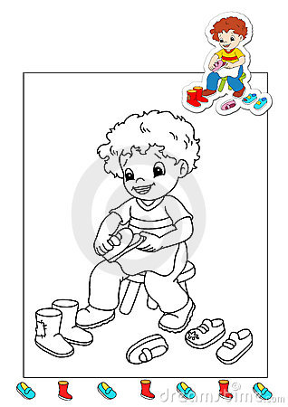](http://thumbs.dreamstime.com/z/coloring-book-works-16-cobbler-15020802.jpg)

[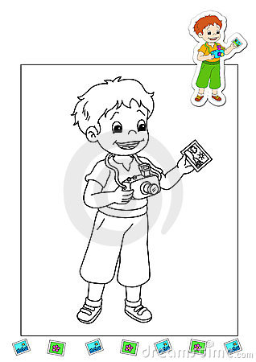](http://thumbs.dreamstime.com/z/coloring-book-works-14-photographer-15019164.jpg)

[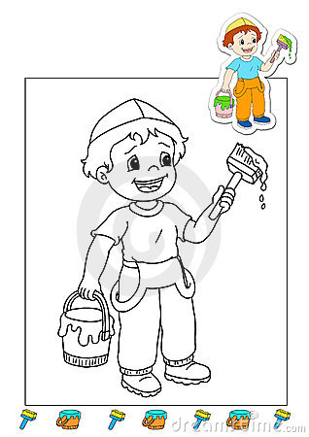](http://thumbs.dreamstime.com/z/coloring-book-works-3-bleaches-15019087.jpg)

[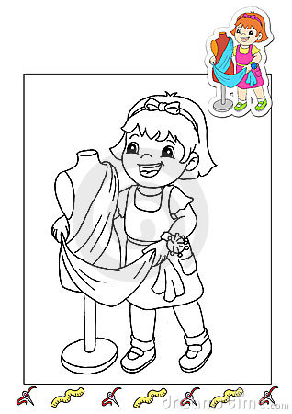](http://thumbs.dreamstime.com/z/coloring-book-works-30-tailor-15139890.jpg)

[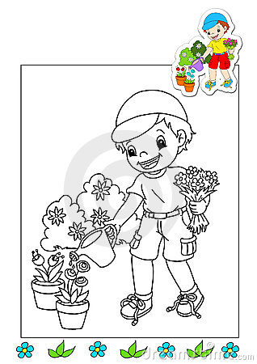](http://thumbs.dreamstime.com/z/coloring-book-works-21-gardener-15028858.jpg)

[](http://thumbs.dreamstime.com/z/coloring-book-works-20-chemical-15028852.jpg)

[](http://thumbs.dreamstime.com/z/coloring-book-works-5-singer-14782879.jpg)

[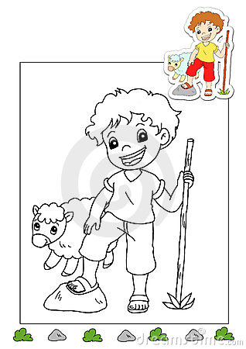](http://thumbs.dreamstime.com/z/coloring-book-works-37-shepherd-15355829.jpg)

[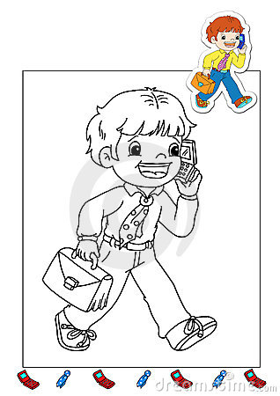](http://thumbs.dreamstime.com/z/coloring-book-works-18-manager-15020821.jpg)

[](http://thumbs.dreamstime.com/z/coloring-book-works-15-lawyer-15020793.jpg)

[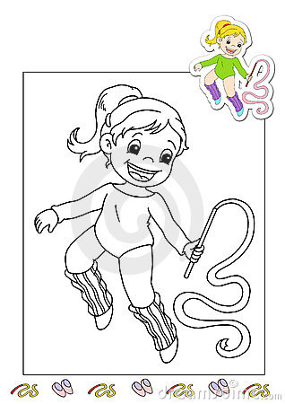](http://thumbs.dreamstime.com/z/coloring-book-works-4-gymnast-15019124.jpg)

[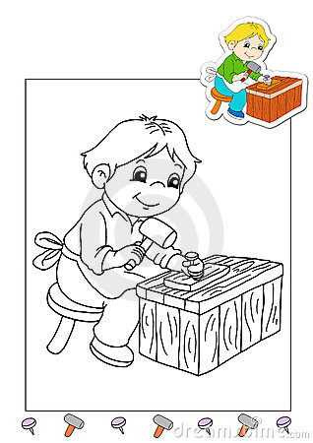](http://thumbs.dreamstime.com/z/coloring-book-works-11-carpenter-15012340.jpg)

[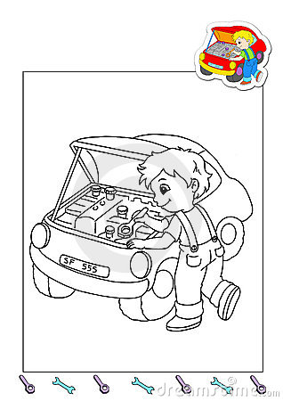](http://thumbs.dreamstime.com/z/coloring-book-works-22-mechanic-15028865.jpg)

[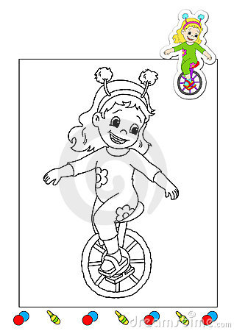](http://thumbs.dreamstime.com/z/coloring-book-works-19-acrobat-15020830.jpg)

[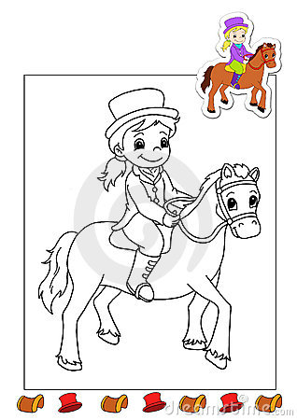](http://thumbs.dreamstime.com/z/coloring-book-works-17-horsewoman-15020813.jpg)

[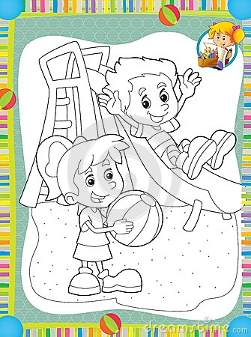](http://thumbs.dreamstime.com/z/page-exercises-kids-coloring-book-illustration-children-29242787.jpg)

[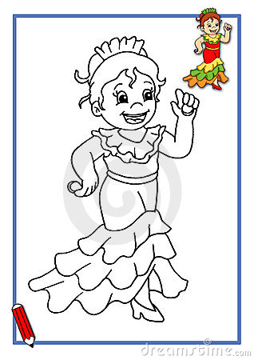](http://thumbs.dreamstime.com/z/spanish-dancer-to-be-color-20753730.jpg)

[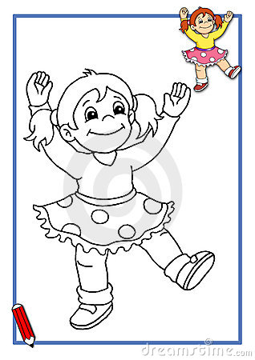](http://thumbs.dreamstime.com/z/dancer-to-be-color-21137416.jpg)

[](http://thumbs.dreamstime.com/z/gymnast-to-be-color-21137430.jpg)

[](http://thumbs.dreamstime.com/z/girl-drawing-characters-21543309.jpg)

[](http://thumbs.dreamstime.com/z/santa-claus-16190267.jpg)

[](http://thumbs.dreamstime.com/z/santa-claus-16190288.jpg)



