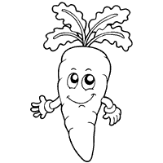

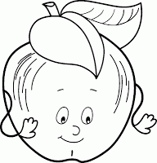

[](http://www.google.com.vn/imgres?q=free+coloring+pages+fruits+and+vegetables&um=1&hl=vi&biw=1311&bih=564&tbm=isch&tbnid=hSMaVyYcnismQM:&imgrefurl=http://free-coloring-for-kids.blogspot.com/2012/03/coloring-fruits-and-vegetables-part-5.html&docid=Tg6BSea-enNSiM&imgurl=http://2.bp.blogspot.com/-gsxgyJLpHp8/T2DCWQMdjRI/AAAAAAAACCk/-HhF3p4YHOY/s200/Fruits+and+Vegetables+6.gif&w=955&h=961&ei=FHfVUdTfG4-kiQedj4HYBQ&zoom=1&iact=hc&vpx=122&vpy=222&dur=780&hovh=225&hovw=224&tx=104&ty=107&page=2&tbnh=142&tbnw=141&start=26&ndsp=36&ved=1t:429,r:27,s:0,i:163)

[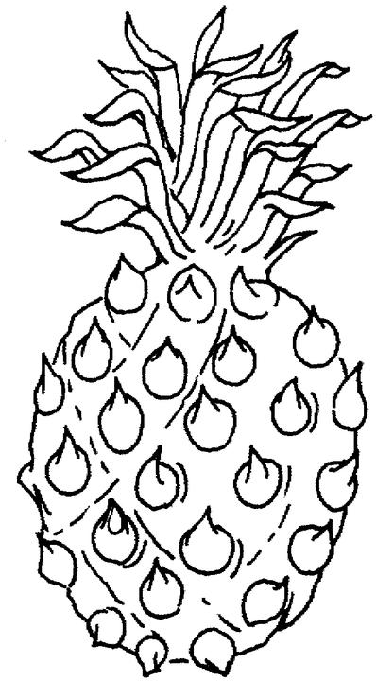](http://www.coloringpages1001.com/coloring-pages/fruit-and-vegetables/fruit-and-vegetables-coloring-pages-3.jpg)

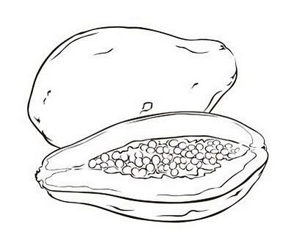

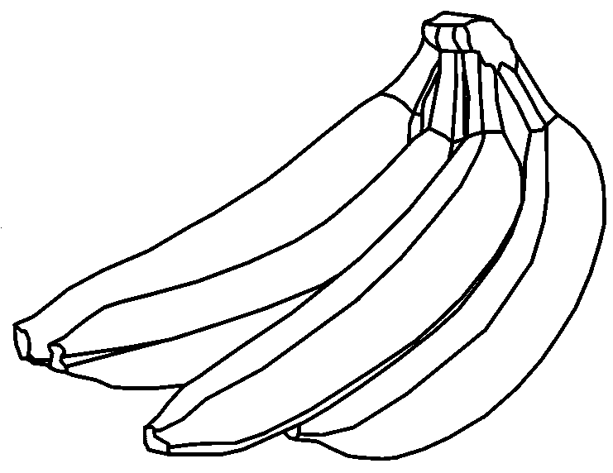

[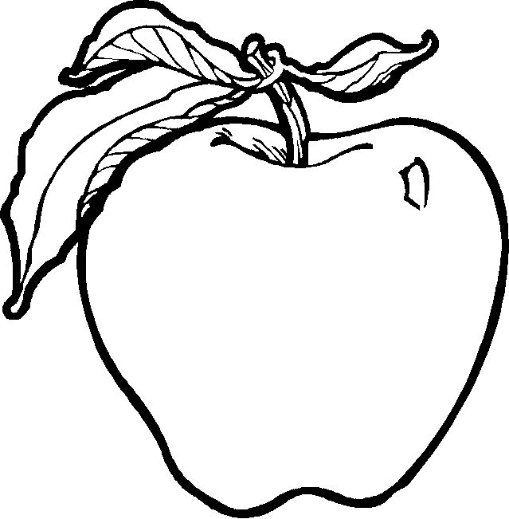](http://www.coloringpages1001.com/coloring-pages/fruit-and-vegetables/fruit-and-vegetables-coloring-pages-7.gif)

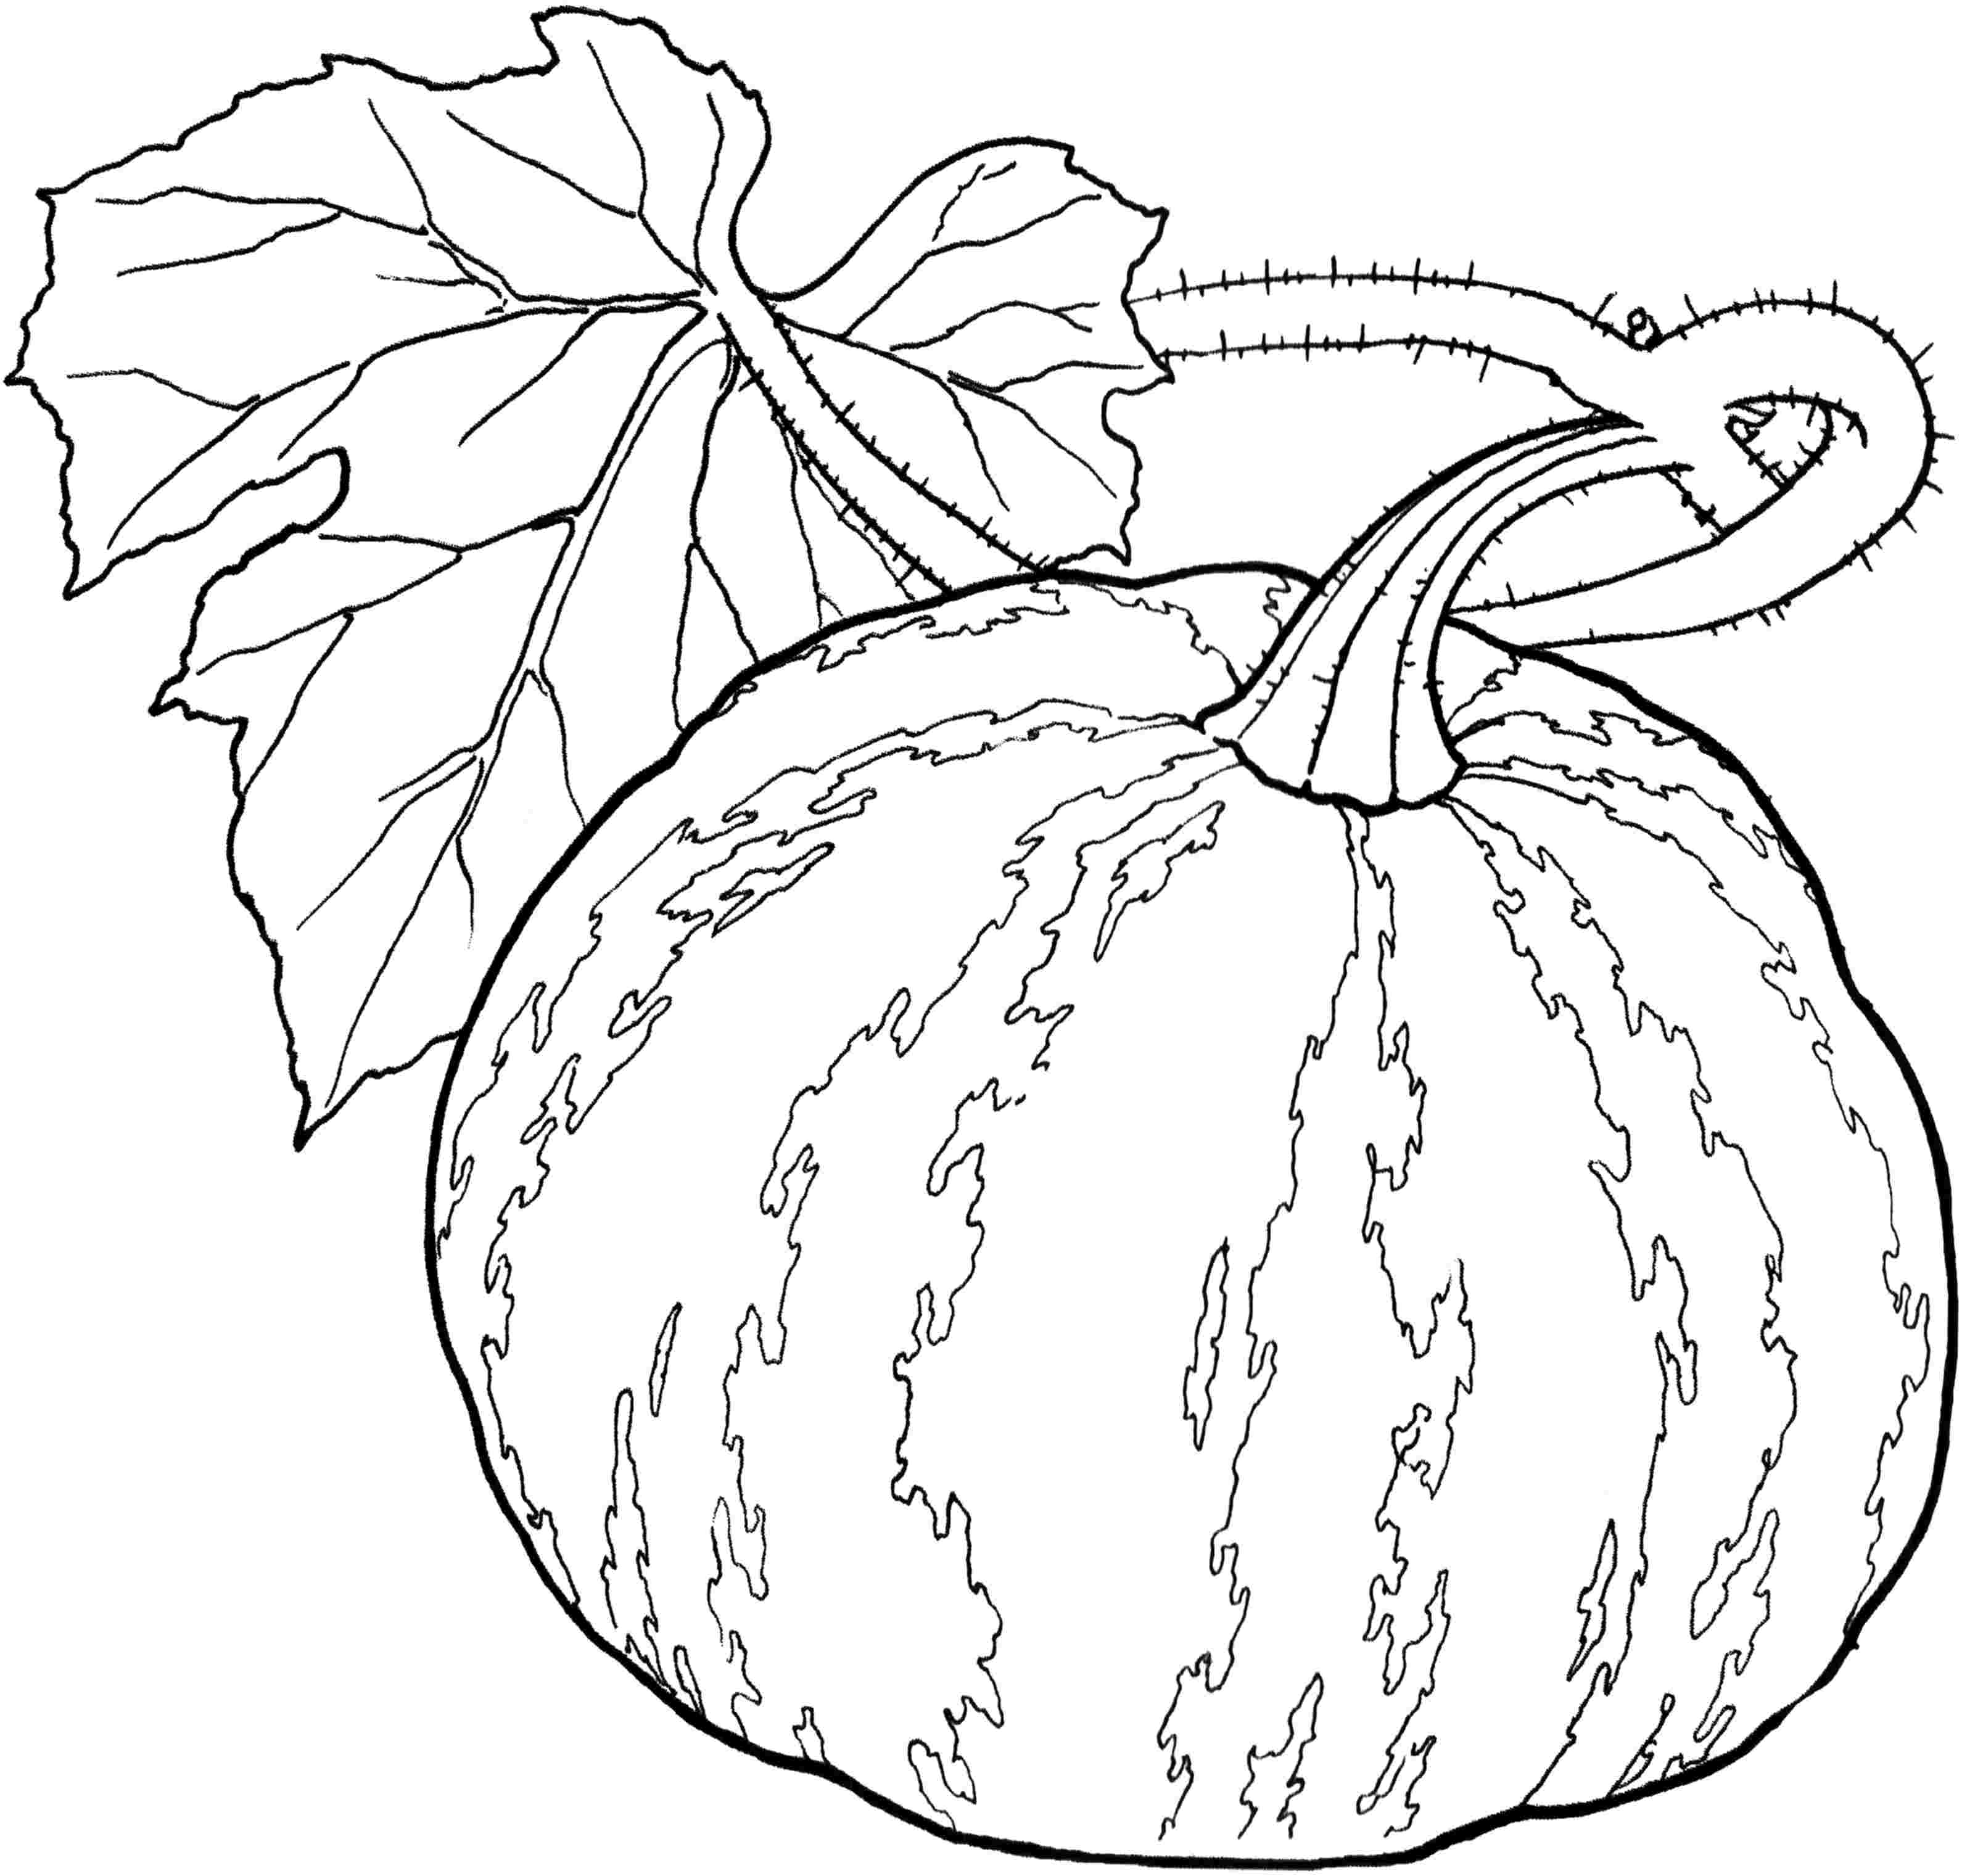

[](http://www.google.com.vn/imgres?q=free+coloring+pages+fruits+and+vegetables&um=1&hl=vi&biw=1311&bih=564&tbm=isch&tbnid=I3aZZIl4U1FhOM:&imgrefurl=http://kootation.com/kids-under-7-vegetables-coloring-pages.html&docid=TO5OKHK-anIbCM&imgurl=http://1.bp.blogspot.com/-VUS1wwOe72c/UOk1_MoSA8I/AAAAAAAAC8c/vGWdssvgQ5g/s1600/fruit&vegetables%20part%206-7.gif&w=1079&h=1007&ei=FHfVUdTfG4-kiQedj4HYBQ&zoom=1&iact=hc&vpx=1033&vpy=229&dur=1482&hovh=217&hovw=232&tx=131&ty=111&page=2&tbnh=133&tbnw=142&start=26&ndsp=36&ved=1t:429,r:52,s:0,i:238)

[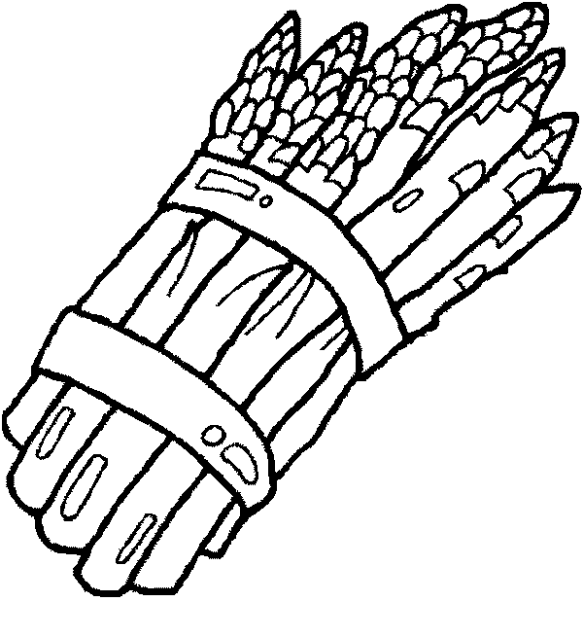](http://www.coloringpages1001.com/coloring-pages/fruit-and-vegetables/fruit-and-vegetables-coloring-pages-8.gif)

[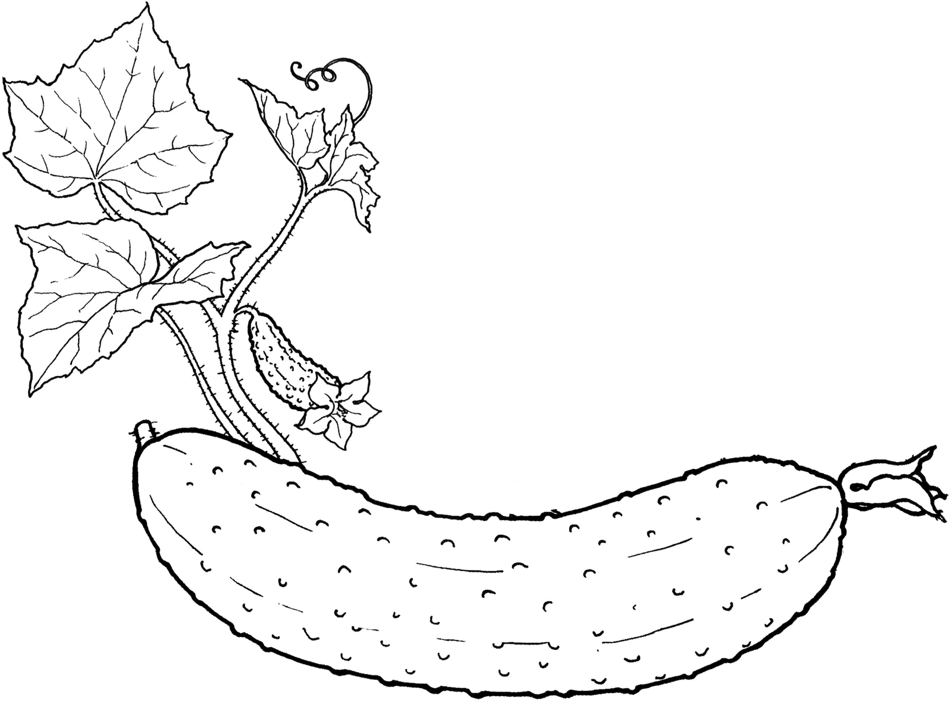](http://kidsprintablescoloringpages.com/data/media/50/Vegetables%20coloring%20pages%208.jpg)

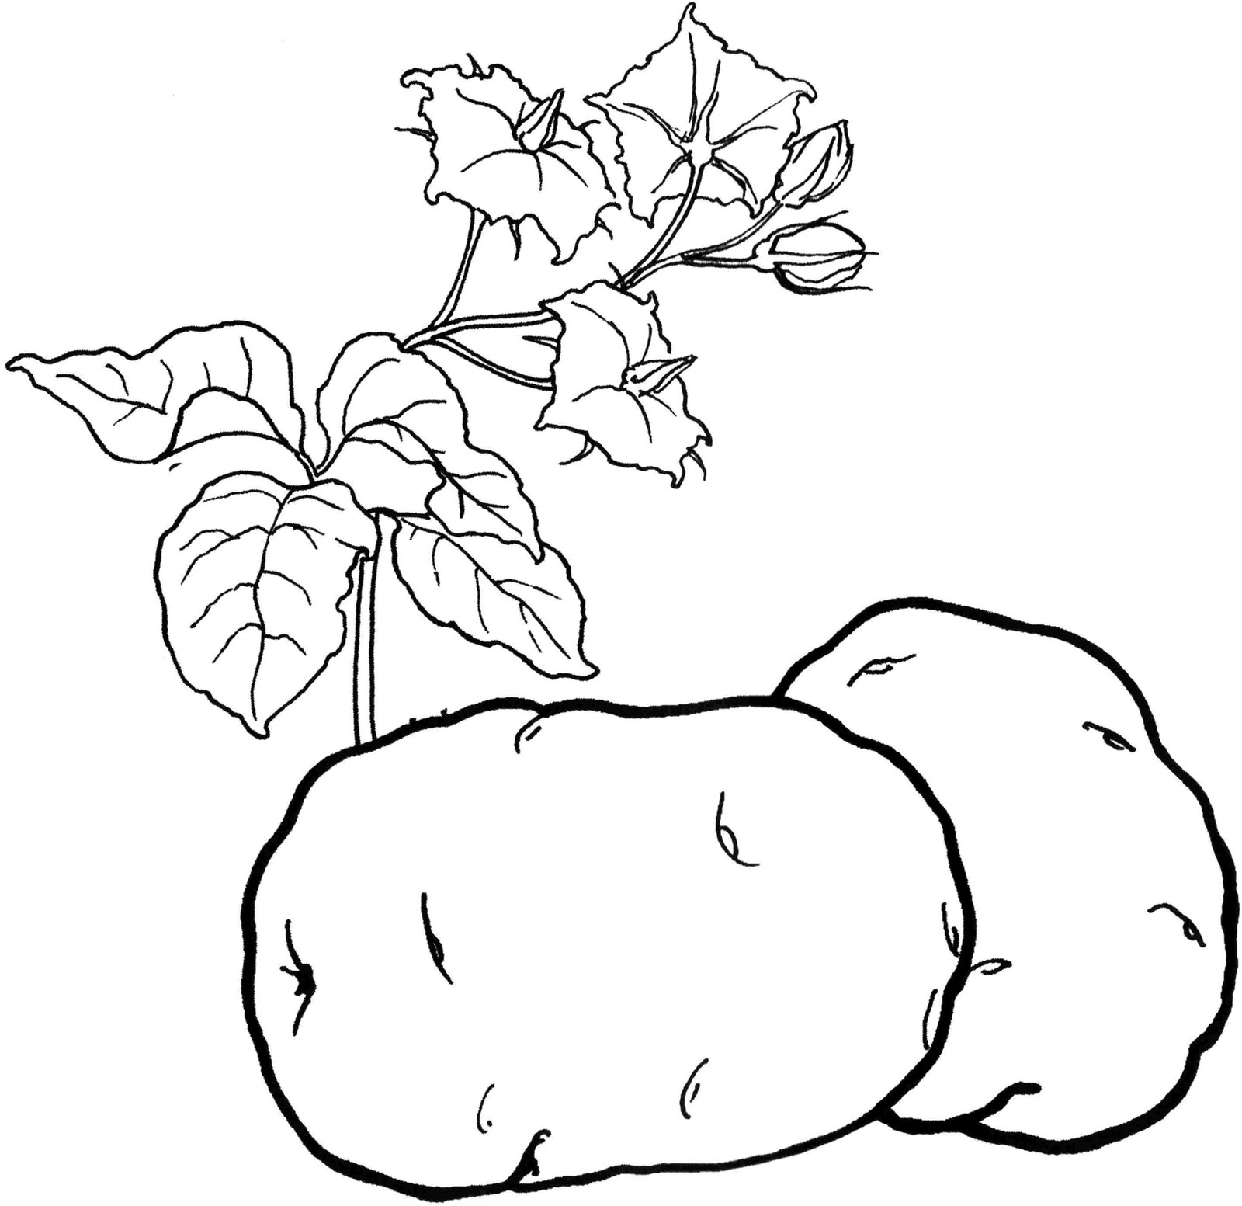

[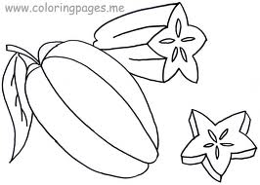](http://www.google.com.vn/imgres?q=coloring+pages+fruits&start=212&um=1&hl=vi&biw=1311&bih=564&tbm=isch&tbnid=LQDjw_NiSHh02M:&imgrefurl=http://coloringpages.me/star-fruit-coloring-pages/&docid=IiTv_NWsxvbfgM&imgurl=http://coloringpages.me/wp-content/uploads/2012/06/Star-Fruit-Coloring-Pages-1024x731.jpg&w=1024&h=731&ei=93XVUbGWF4yIiQf-5IC4DA&zoom=1&iact=rc&dur=156&page=7&tbnh=137&tbnw=192&ndsp=39&ved=1t:429,r:46,s:200,i:142&tx=93&ty=68)

[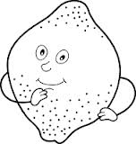](http://www.google.com.vn/imgres?q=free+coloring+pages+fruits+and+vegetables&start=251&um=1&hl=vi&biw=1311&bih=564&tbm=isch&tbnid=-R1WCHehOxXioM:&imgrefurl=http://printablecolouringpages.co.uk/?s=parts%20of%20fruits&page=1&docid=E7noiH6hjNMIQM&imgurl=http://1.bp.blogspot.com/-kuTpew8FsmE/UOk1_-IqBPI/AAAAAAAAC8k/dXTfB6QQf-M/s1600/fruit&vegetables+part+6-9.gif&w=190&h=200&ei=pHnVUfTuHIXeigeQ8YHoBg&zoom=1&iact=hc&vpx=793&vpy=185&dur=749&hovh=160&hovw=152&tx=86&ty=67&page=8&tbnh=140&tbnw=133&ndsp=35&ved=1t:429,r:57,s:200,i:175)

